This Guide has been developed for use with ACEM Mentoring Module
3F Developing the mentee: Difficult Conversations, Change and Conflict

This Questions Guide will be useful for anyone that needs to have a difficult conversation in the workplace. It has been framed on a coaching approach, used by mentors, which facilitates conversations that are supportive, constructive and productive, regardless of the topic. It lists specific questions to ask yourself and the mentee along the way.

It is important to note that it is NOT the role of a mentor to undertake performance management conversations or provide negative feedback from others. The mentor does have a role in SUPPORTING the trainee going through these processes, but they are NOT the person responsible for having those difficult conversations.
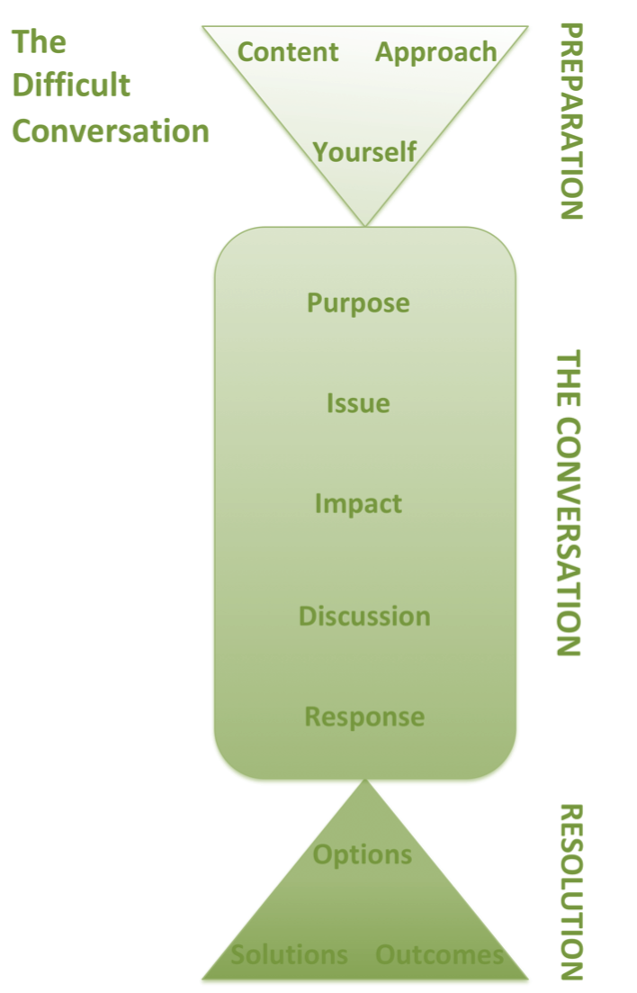

This framework provides a structure for approaching difficult conversations. There are three components to consider:

Preparation
- Think about what needs to be said, how best to say it, and how your attitude will influence the conversation

The Conversation
- A structured approach will ensure the dialogue is meaningful, supportive and productive

Resolution
- Dealing with the issue in partnership with the recipient is the final aim of the conversation

PREPARATION
Prepare the content
Gather information:
What are the facts?
What is my interpretation of the facts?
What is opinion or speculation?

Label the issue:

What is the core or central issue?

What exactly are the behaviours that are causing a problem?

Provide examples – be specific.

Are there related issues that may distract from the central issue are best avoided at this time?

Explain the impact:

How is the issue impacting performance?

How are their behaviours affecting others?

Why is it important for their attitude or behaviour to change?

What will happen if there is NO action or change?

Be constructive:

How can I make this part of something good?

Prepare yourself
Inquiry mindset

What assumptions am I making?
What are my preconceived notions about the issue?

Your motivations

Why do I feel this conversation needs to occur?

What barriers and hindrances are there within me?

What are my fears and hesitations?

HAVING THE CONVERSATION
Self-check:
Are you prepared? ☐ Can you give your full attention? ☐ Ready for a discussion, not an inquisition or a reprimand? ☐

Explain that you would like to discuss a difficult or challenging issue
Label the issue: | Write it here:
Outline the impact: | Write it here:
Encourage discussion: | Make notes on their perspectives here:
Listening skills
- don’t interrupt
- paraphrase
- probe with questions
- watch body language

Be receptive
- listen for learning not convincing
Acknowledge and validate their perspective
Your response:  - Use “I” statements  - Articulate your thinking  - Use sign posts  - Summarise |  | Make notes here:

RESOLUTION
Agreed outcomes:
What outcome do they see as acceptable?

How does that differ from the desired outcome you see?

How can the outcomes be modified to meet in the middle?

How can we work this out?

Commit to action:

What are we going to do next?

And by when?

What support will I commit to providing for the recipient?

Reflect:

Was I sufficiently prepared?

What went well?

What could I improve on for next time?

What specific skills areas do I need to work on?

MOTIVATING CHANGE
Select one or more of the approaches below to generate desire and motivation for change
Look back to look forward
Spend as much time as you need in the past to determine what is important to the person.
Understand their journey to the current crossroads.
What has happened in the past?
What are they letting go of?
What are their fears or barriers?
Pros and cons
Discuss change vs staying the same. Help them make a list of pros and cons for each
Pros:
What looks appealing about this choice?
What are the advantages?

Cons:
What is bad about this choice?
What are the disadvantages?
What are the barriers or challenges for this choice?
Three scenarios
ASK them to imagine and describe:

Best case scenario

Worst case scenario

Interesting case scenario

DEALING WITH CONFLICT
Use these simple questions to understand your position and facilitate constructive conflict management
What do you hope to achieve in the conversation?
What are your needs? What are their needs?
What are your non-negotiables?

